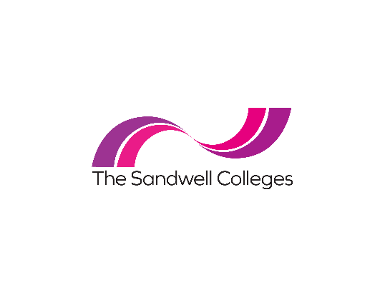
The Sandwell Colleges has adopted a policy of actively promoting equality of opportunity for all. Applicants who meet the essential criteria of the person specification will be granted an interview, irrespective of age, gender, marital status, sexual orientation, religion, disability or ethnic origin. In order to develop the positive policy of equal opportunities and to ensure that it is fully effective, applicants are asked to complete the monitoring form. All information on this form will be held confidentially and will not be provided to the shortlisting panel for selection purposes.
Gender (click inside the appropriate box) | Male ☐ | Female ☐ | Other ☐ Prefer not to say ☐
Marital Status (click inside the appropriate box) | Married ☐ | Single ☐ | Civil Partnership ☐ | Widowed ☐ | Prefer not to say ☐

Which age group do you belong to? (click inside the appropriate box) |  |  |  | 16-19 ☐ | 20-24 ☐ | 25-29 ☐ | 30-34 ☐
35-39 ☐ | 40-44 ☐ | 45-49 ☐ | 50-54 ☐ | 55-59 ☐ | 60-64 ☐ | 65+ ☐ | Prefer not to say ☐

I would describe my ethnic origin as: (click inside the appropriate box)
White - English/Welsh/Scottish/Northern Irish/British ☐ | Asian/Asian British - Bangladeshi ☐
White - Irish ☐ | Asian/Asian British - Sikh ☐
White - Gypsy / Irish Traveller ☐ | Asian/Asian British - Chinese ☐
White - any other ☐ | Asian/Asian British - any other ☐
Mixed/Multiple ethnic groups - White & Black Caribbean ☐ | Black/African/Caribbean/Black British - African ☐
Mixed/Multiple ethnic groups - White & Black African ☐ | Black/African/Caribbean/Black British - Caribbean ☐
Mixed/Multiple ethnic groups - White & Asian ☐ | Black/African/Caribbean/Black British - any other ☐
Mixed/Multiple ethnic groups - any other ☐ | Other ethnic group - Arab ☐
Asian/Asian British – Indian ☐ | Other ethnic group - any other ☐
Asian/Asian British – Pakistani ☐ | Prefer not to say ☐

My Sexual Orientation is toward someone of: (click inside the appropriate box)
A different sex ☐ | Both sexes ☐
Same sex ☐ | Prefer not to say ☐

I would describe my religious beliefs as: (click inside the appropriate box)
Christian ☐ | Muslim ☐
Hindu ☐ | Buddhist ☐
Sikh ☐ | Jewish ☐
None ☐ | Atheism ☐
Prefer not to say ☐ | Other ☐
Following implementation of the Equality Act 2010, employers are now committed to providing people with disabilities, an opportunity to compete fairly for jobs. The Equality Act 2010 states that “a person has a disability for the purpose of the Act if you have a physical or mental impairment that has a ‘substantial’ and ‘long-term’ negative effect on your ability to do normal daily activities”.
Disability (click inside the appropriate box)
Do you consider yourself to have a disability?* | Yes ☐ No ☐ Prefer not to say ☐
*If you do not consider that you meet this definition but consider that you have a disability, then please advise us in the section below. Please let us know how we can support you if you require assistance or adjustments to be made to enable you to attend and participate in the interview if selected.
Disability:
Assistance or adjustments required:

